**Appendix 1 – The Current site**

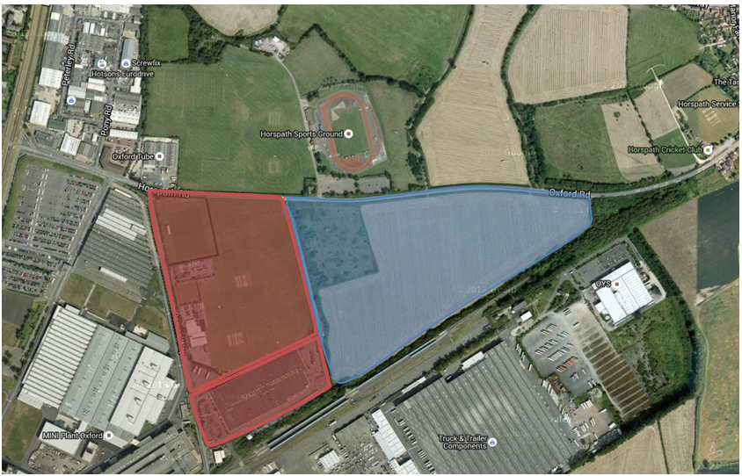

**At the time of writing the report there are the following facilities**

Senior football pitch 5 Academy buildings 1

Youth football pitch 1 Cricket nets 1

Junior football pitch 3 Cricket pitch 2

Main building 1

**Example layout of the new site**



Land in red is new facility including new all-weather pitches indicated in green.